**Lab 3 Pre-lab Report:**

**Part 1.1:**

|  |  |  |  |
| --- | --- | --- | --- |
| **en** | **d** | **qprev** | **q** |
| 1 | 0 | N/A | 0 |
| 0 | 0 | 0 | 0 |
| 0 | 1 | 0 | 0 |
| 1 | 1 | 0 | 1 |
| 0 | 1 | 1 | 1 |

**Part 1.2:**

**RTL View:**

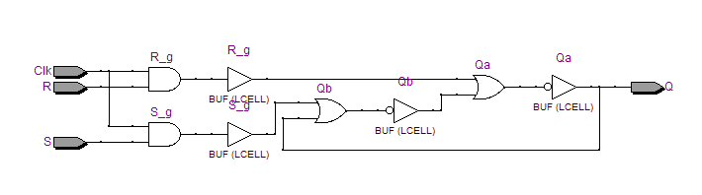

**Technology View:**

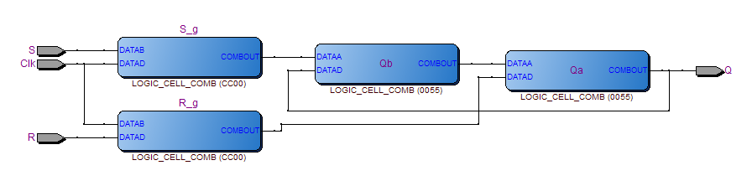

**Part 1.3:**

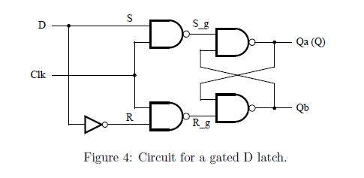

**Part 1.4:**

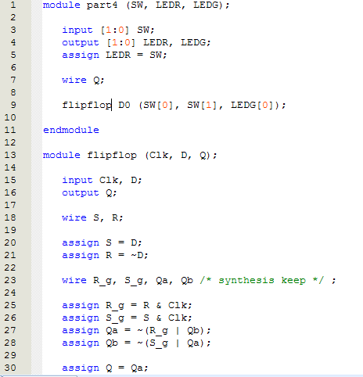

**Part 1.5:**

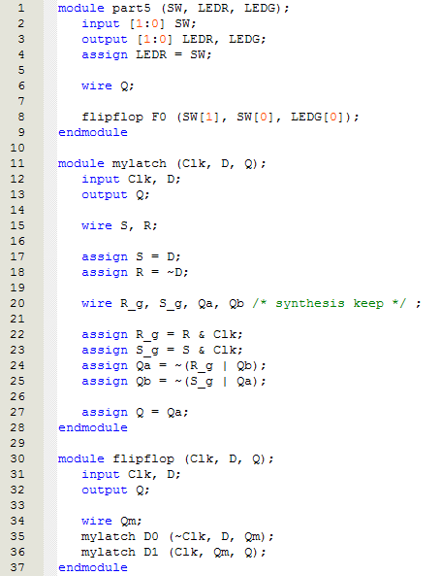

**Part 1.6:**

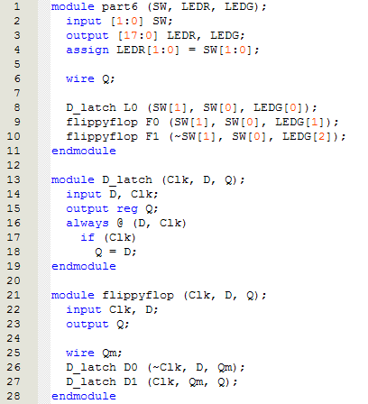

**Part 1.7:**

